Selah C. Williams

Professor Kathleen Volk-Miller

WRIT 312-001

July 18, 2023

Blog Post (Draft) for Kotaku

**This Cute Lil’ Game is an Adorable Masterpiece**

*Lil’ Gator Game* is a *Breath of the Wild*-like romp that embodies the fun of being a kid, and the bittersweet reality of growing up

**By** **Selah Williams** Published July 18, 2023 | Comments (0)

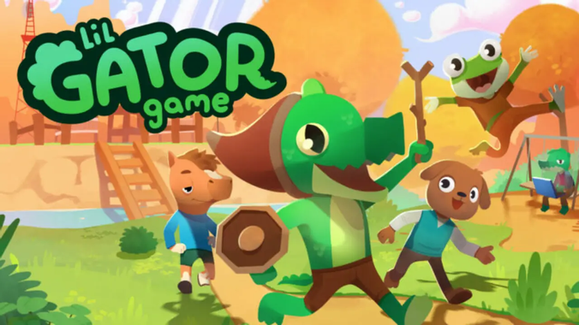

Screenshot: MegaWobble / STEAM

It’s easy to feel inseparable from your older siblings at the start, but what happens when they grow up?

For fans of [Legend of Zelda: Breath of the Wild](https://www.zelda.com/breath-of-the-wild/) and [Tears of the Kingdom](https://zelda.com/tears-of-the-kingdom/), Lil’ Gator Game is a lovely homage to the world of make-believe. Like seeing through the eyes of a child once more, the player is introduced to a wonderful [slice of life](https://tvtropes.org/pmwiki/pmwiki.php/Main/SliceOfLife) experience that portrays the amazing power a child's imagination and the difficulty of maintaining that innocent wonder as we grow older. While exploring a cute island, slashing cardboard creatures, and completing various quests, you’ll make new friends along the way, expanding your home base and getting some cool new gadgets to take with you to your next adventure.

For as long as Lil' Gator can remember, he and his sister have grown up together on the island. His "Big Sis" makes Zelda-like quests for her younger brother, and both have a great time exploring the island and defeating cardboard enemies that stand in their way. Only now, in the present, Big Sis has graduated from college and Lil' Gator is a little older. While she is home for fall break, Lil' Gator does his best to get her to play with him again, only for her to decline, being swamped with classwork. Because of this, Lil' Gator bands together with his friends to make the best home base ever on the island, something that will make Big Sis eager to play with them. A failproof plan! Right?

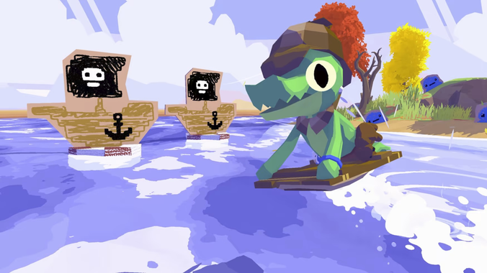

Screenshot: MegaWobble / STEAM

Climbing mountains, skating across the water, gliding across vast terrains, Lil’ Gator will stop at nothing to get his sister on board. The writing of the game’s story is a breath of fresh air, as the dynamic between both siblings is explored in full. Each character has their own unique contribution that makes the island feel bigger than it is, contributing greatly to the overall open-world experience.

This game is short in comparison to most that have come out this year, but the painstaking detail to the almost children’s book-like art style and elaborate physics engine makes the sky the limit on how your experience traversing the island will feel. There’s even something in it for completionists as well if you so decide to extend your stay. This elaborate but simple game is sure to be a pleasant six hours, that is, unless you wish to see what else the island has in store for you?

Word Count: ~830 (2 pages)

Site Analysis

The target audience of the overarching site is young (millennials and younger) individuals who enjoy video games. The primary objective of the site is to discuss—through opinion pieces and reviews—about all things video games. The articles are written by a hired team of writers. This is a monetized blog. The website seems user-friendly.